# Lab: Sets and Maps Advanced

This document defines the lab for ["Java Advanced" course @ Software University](https://softuni.bg/modules/59/java-advanced). Please submit your solutions (source code) of all below described problems in [Judge](https://judge.softuni.bg/Contests/1462/Sets-And-Maps-Advanced-Lab).

## Sets

### Parking Lot

Write a program that:

* Records **car number** for every car that enter in the **parking lot**
* Removes **car number** when the car go out

#### Input

The input will be string in format **[direction, carNumber]**

The input ends with string **"END"**

#### Output

Print the output with all car numbers which are in parking lot

#### Examples

|  |  |
| --- | --- |
| **Input** | **Output** |
| IN, CA2844AA  IN, CA1234TA  OUT, CA2844AA  IN, CA9999TT  IN, CA2866HI  OUT, CA1234TA  IN, CA2844AA  OUT, CA2866HI  IN, CA9876HH  IN, CA2822UU  END | CA9999TT  CA2844AA  CA9876HH  CA2822UU |
| IN, CA2844AA  IN, CA1234TA  OUT, CA2844AA  OUT, CA1234TA  END | Parking Lot is Empty |

#### Hints

* Car numbers are **unique**
* Use the methods **isEmpty()**

### SoftUni Party

There is a party in SoftUni. Many guests are invited, and they are two types: **VIP** and **regular**.   
When guest comes, you have to check if he/she **exist** in any of two reservation lists.

All reservation numbers will be with **8 chars.**

All **VIP** numbers start with **digit.**

There will be 2 command lines. First is "PARTY" - party is on and guests start coming.  
Second is **"END"** - then party is over, and no more guest will come.

Output shows all guests, who didn't come to the party (**VIP** must be first).

#### Examples

|  |  |  |  |
| --- | --- | --- | --- |
| **Input** | **Output** | **Input** | **Output** |
| 7IK9Yo0h  9NoBUajQ  Ce8vwPmE  SVQXQCbc  tSzE5t0p  PARTY  9NoBUajQ  Ce8vwPmE  SVQXQCbc  END | 2  7IK9Yo0h  tSzE5t0p | m8rfQBvl  fc1oZCE0  UgffRkOn  7ugX7bm0  9CQBGUeJ  2FQZT3uC  dziNz78I  mdSGyQCJ  LjcVpmDL  fPXNHpm1  HTTbwRmM  B5yTkMQi  8N0FThqG  xys2FYzn  MDzcM9ZK  PARTY  2FQZT3uC  dziNz78I  mdSGyQCJ  LjcVpmDL  fPXNHpm1  HTTbwRmM  B5yTkMQi  8N0FThqG  m8rfQBvl  fc1oZCE0  UgffRkOn  7ugX7bm0  9CQBGUeJ  END | 2  MDzcM9ZK  xys2FYzn |

### "Voina" – Number Game

Write a program that:

* Reads 20 numbers for both players, separated with " " (single space)
* Every player can hold only **unique** numbers

Each Round both players get the **top number** from their own deck. Player with the bigger number get both numbers and add it on the **bottom** of his own sequence

Game ends after **50 rounds** or if any player **lose all** of his numbers

#### Input

* Numbers – **Integer**

#### Output

* Output must be **"First Player Win!"**, **"Second Player Win!"** or **"Draw!"**

#### Examples

|  |  |
| --- | --- |
| **Input** | **Output** |
| 26 58 16 92 44 65 65 77 57 23 71 57 7 52 85 44 32 70 38 23  43 95 33 51 62 93 57 55 0 31 32 95 68 34 30 51 37 32 11 97 | Second player win! |
| 74 78 82 42 19 39 29 69 20 42 31 77 57 36 76 26 4 9 83 42  15 43 80 71 22 88 78 35 28 30 46 41 76 51 76 18 14 52 47 38 | First player win! |

#### Hints

* Use Iterator<E> and **next()** for finding top number in decks
* Think where to check if any player is without cards
* When you find top number, be sure to remove it immediately

#### Solution

You might help yourself with the code below:

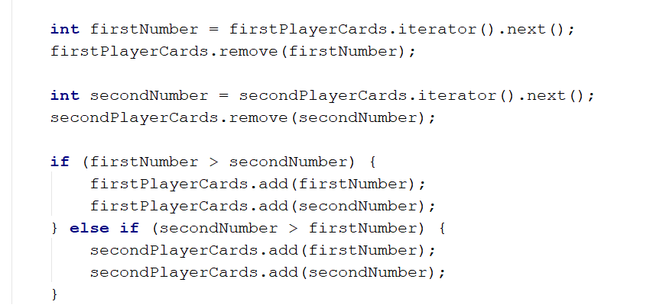

## Maps

### Count Real Numbers

Write a program that counts the occurrence of real **numbers**. The input is a single line with real numbers separated by spaces. Print the numbers in the order of appearance. All **numbers** must be formatted to one digit after the decimal point.

#### Examples

|  |  |
| --- | --- |
| **Input** | **Output** |
| -2.5 4 3 -2.5 -5.5 4 3 3 -2.5 3 | -2.5 -> 3  4.0 -> 2  3.0 -> 4  -5.5 -> 1 |
| 2.3 4.5 4.5 5.5 5.5 2.3 3.0 3.0 4.5 4.5 3.0 3.0 4.0 3.0 5.5 3.0 2.3 5.5 4.5 3.0 | 2.3 -> 3  4.5 -> 5  5.5 -> 4  3.0 -> 7   * 1. -> 1 |

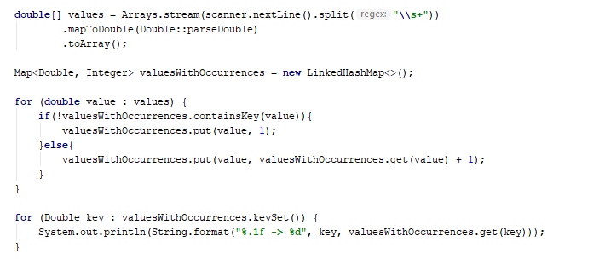

### Average Students Grades

Write a program, which reads the **name** of a student and their **grades** and **adds** them to the **student record**, then **prints** **grades** along with their **average grade – ordered the output by the names of the students**.

#### Input

On the first line **N** – the number of students, then on the next **N** lines student name with grade.

#### Examples

|  |  |
| --- | --- |
| **Input** | **Output** |
| 7  Stephan 5.20  Maria 5.50  Stephan 3.20  Maria 2.50  Alex 2.00  Maria 3.46  Alex 3.00 | Alex -> 2.00 3.00 (avg: 2.50)  Maria -> 5.50 2.50 3.46 (avg: 3.82)  Stephan -> 5.20 3.20 (avg: 4.20) |
| 4  Alex 4.50  Peter 3.00  Alex 5.00  Peter 3.66 | Alex -> 4.50 5.00 (avg: 4.75) Peter -> 3.00 3.66 (avg: 3.33) |
| 5  George 6.00  George 5.50  George 6.00  Alex 4.40  Peter 3.30  Peter 4.50 | Alex -> 4.40 (avg: 4.40)  George -> 6.00 5.50 6.00 (avg: 5.83)  Peter -> 3.30 (avg: 3.30) |

#### Hints

* Use a **TreeMap** (String 🡪 ArrayList<Double>)
* Check if the name **exists** before adding the grade. If it doesn’t, add it to the map.
* Pass through all **key-value pairs** in the map and print the results.
* Think of way to get the average grades for each student.
* You can do that with an ordinary loop or with **Stream API**

### Product Shop

Write a program that prints information about food shops in Sofia and the products they store. Until the "Revision" command you will receive an input in the format: "{shop}, {product}, {price}"

Take in mind that if you receive a shop you already have received, you must collect its product information.

Your output must be ordered by shop name and must be in the format:

{shop}->

Product: {product}, Price: {price}

The price should be formated to one digit after the decimal point.

#### Examples

|  |  |
| --- | --- |
| **Input** | **Output** |
| lidl, juice, 2.30  fantastico, apple, 1.20  kaufland, banana, 1.10  fantastico, grape, 2.20  Revision | fantastico->  Product: apple, Price: 1.2  Product: grape, Price: 2.2  kaufland->  Product: banana, Price: 1.1  lidl->  Product: juice, Price: 2.3 |
| tmarket, peanuts, 2.20  GoGrill, meatballs, 3.30  GoGrill, HotDog, 1.40  tmarket, sweets, 2.20  Revision | GoGrill->  Product: meatballs, Price: 3.3  Product: HotDog, Price: 1.4  tmarket->  Product: peanuts, Price: 2.2  Product: sweets, Price: 2.2 |

### Cities by Continent and Country

Write a program to read **continents**, **countries** and their **cities**, put them in a **nested map** and **print** them in the order of first appearance.

#### Examples

|  |  |
| --- | --- |
| **Input** | **Output** |
| 9  Europe Bulgaria Sofia  Asia China Beijing  Asia Japan Tokyo  Europe Poland Warsaw  Europe Germany Berlin  Europe Poland Poznan  Europe Bulgaria Plovdiv  Africa Nigeria Abuja  Asia China Shanghai | Europe:  Bulgaria -> Sofia, Plovdiv  Poland -> Warsaw, Poznan  Germany -> Berlin  Asia:  China -> Beijing, Shanghai  Japan -> Tokyo  Africa:  Nigeria -> Abuja |
| 3  Europe Germany Berlin  Europe Bulgaria Varna  Africa Egypt Cairo | Europe:  Germany -> Berlin  Bulgaria -> Varna  Africa:  Egypt -> Cairo |
| 8  Africa Somalia Mogadishu  Asia India Mumbai  Asia India Delhi  Europe France Paris  Asia India Nagpur  Europe Germany Hamburg  Europe Poland Gdansk  Europe Germany Danzig | Africa:  Somalia -> Mogadishu  Asia:  India -> Mumbai, Delhi, Nagpur  Europe:  France -> Paris  Germany -> Hamburg, Danzig  Poland -> Gdansk |

#### Hints

* Use a **nested** **Map** (String 🡪 (Map🡪 ArrayList<String>))
* Check if the continent **exists** before adding the country. If it doesn’t, **add** it to the dictionary.
* Check if the country **exists**, before **adding** the city. If it doesn’t, add it to the dictionary.

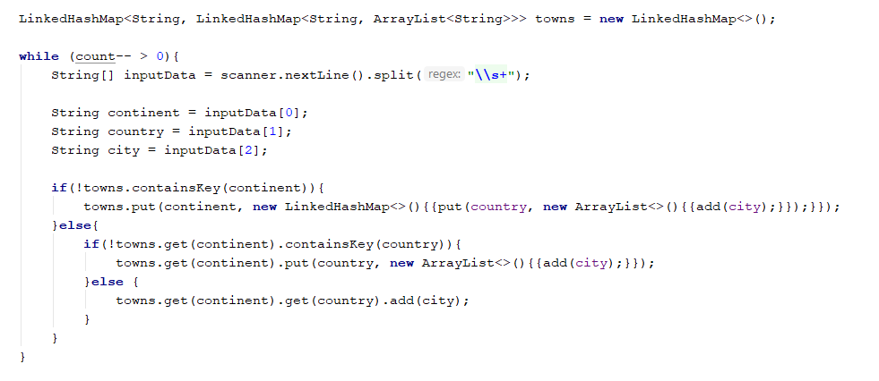

* Pass through all **key-value pairs** in the Map and the values’ key-value pairs and print the results.

### Academy Graduation

Write a program that:

* Reads from console **number** of students for a track
* Reads on **pair of rows**:
  + First line is the **name** of student
  + Second line is his **score** for different number of courses
* Print on console “**{name}** is graduated with **{average scores)**”

#### Examples

|  |  |
| --- | --- |
| **Input** | **Output** |
| 3  George  3.75 5  Maria  4.25 6  Peter  6 4.5 | George is graduated with 4.375  Maria is graduated with 5.125  Peter is graduated with 5.25 |
| 5  George  4.36 5.50 3.30 5.63 2.57 5.75 2.81 4.89  Peter  3.10 5.35 3.30 3.35 5.64 4.99 2.75 4.68  Maria  3.45 3.23 3.03 5.42 5.46 4.15 2.26 5.95  Rosalia  2.08 3.48 3.36 2.73 2.96 4.54 3.70 3.85  George  4.75 4.92 3.78 4.79 4.82 4.75 2.81 2.13 | George is graduated with 4.09375  George is graduated with 4.351249999999999  Maria is graduated with 4.11875  Rosalia is graduated with 3.3375  Peter is graduated with 4.145 |

#### Hints

* Think about **proper type** of map
* **Value** can be **array**
* **Nested loop** and one more **variable** will be need for average score

#### Solution

You might help yourself with the code below:

